For Immediate Release February 28, 2009
Press Release
WDFH FM 90.3 completes new signal expansion
[February 28, 2008 Ossining NY] After more than seven years of work, the area’s only community radio station, WDFH FM 90.3, turned on the power for much more powerful signal this month.
Since 1997, WDFH has beamed its signal from a tower in Ossining. The signal reached an estimated ten thousand potential listeners in Briarcliff, Ossining, Cortlandt, and Croton from a hilltop antenna only fifteen feet above the ground.
The station completed construction and installation of a new antenna in Mount Pleasant, New York, at a much more favorable location during February. Over the past seven years, the station invested $80,000 in capital costs and $150,000 in in-kind services in the legal work, engineering, design, construction, installation, testing, and rewiring for the new antenna project.
The 40 foot mast on which WDFH’s new antenna would be mounted is captured here just moments before being secured to the top of the 125 foot hilltop tower in Mount Pleasant, New York. [January 6, 2009] The antenna installation was completed on January 19 and the new signal went on the air at half power on January 24. The signal went to full power in early February.

“I’m delighted about the expanded coverage, since we’ll be able to reach many more people over the air, as well as online,” noted Jane Botticelli, Ossining resident and co-host of WDFH’s weekly news program In Focus. “Once our studios are rebuilt, we’ll be even more able to reflect the community’s interests in politics, art, and culture.”
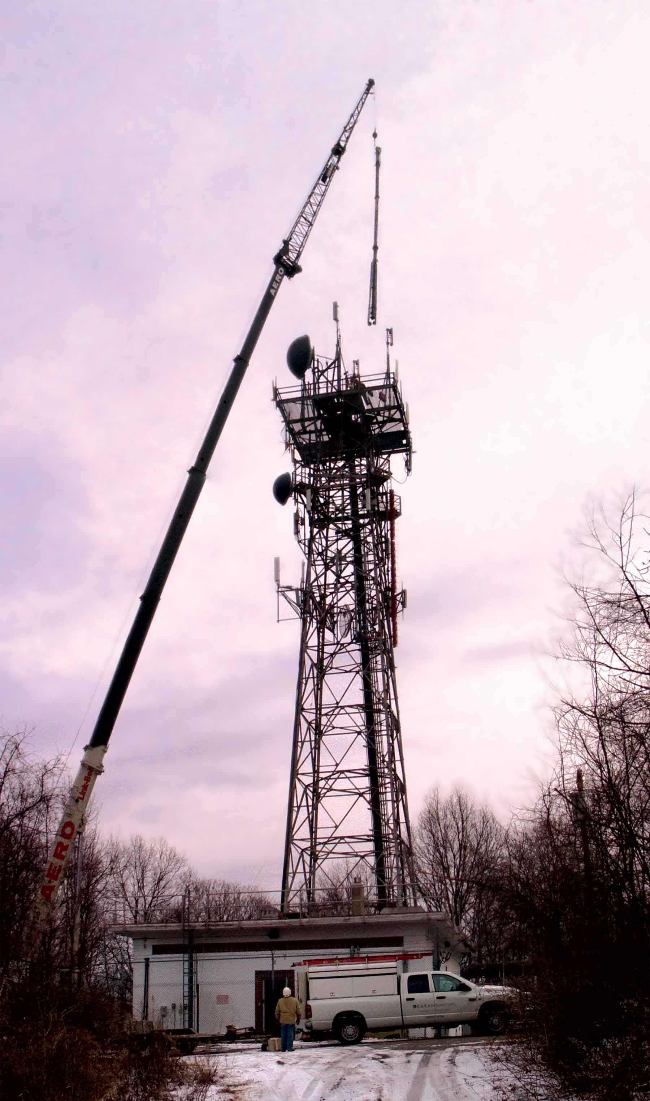
The new antenna is mounted 160 feet above ground level on hilltop tower several miles inland from the old location. The new antenna is now 790 feet above sea level – almost two-thirds the height of the Empire State Building – and 476 feet above average terrain within the listening area.
From this more favorable antenna height, the WDFH signal now projects well to about forty communities in Westchester, Putnam, and Rockland Counties and beyond. From the epicenter in Mount Pleasant, field tests now show the signal is strong to the south as far as Hawthorne, Pleasantville, and Elmsford, to the southwest as far as Westchester County Airport, to the east into western Connecticut, to the northeast and north up I-684 to near Danbury and across southern Putnam and northern Westchester, and to the west across the eastern half of Rockland County.
About WDFH: WDFH is Westchester County and the lower Hudson Valley’s only community radio station. The station’s parent organization is Hudson Valley Community Radio, Inc., a 501(c)(3) nonprofit. WDFH is an affiliate of Pacifica Radio, the Hudson’s Valley source for Democracy Now! and Free Speech Radio News. Listen to WDFH on the radio at 90.3 FM and on-line as podcasts at www.wdfh.org.
Contact: Leo Wiegman, media coordinator, leo@wdfh.org, 914-980-9437

